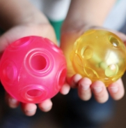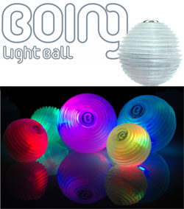

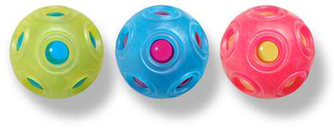



**Boing Pro Light Ball**

Boing light balls change colour with a squeeze of the hand. Covered in an ergonomically designed ribbed rubber they are perfect for dazzling juggling shows, magic games or just as cool tactile mood lights. Choose from 3 light modes (constant colour, slow phase and fast phase) and 7 colours, moving from one to the next simply by squeezing the ball. Ages 3 years and up

**Xa Xa Ball**

Not only is XaXa a toy for creative discovery, it can also be used to teach about colour and sound. Whether used as a container for a precious little gift, a secret message or even as a role-play accessory, XaXa spurs the imagination, trains motor skills and sharpens the senses. The balls and skins come in pairs of primary colours, which you can recombine to get all the colours of the rainbow. Ages 3 years and up

**Product Information**

|  |  |  |  |  |  |  |  |  |
| --- | --- | --- | --- | --- | --- | --- | --- | --- |
| **Product Code** | **Description** | **Colour** | **Length (cm)** | **Width (cm)** | **Depth (cm)** | **Weight (Kg)** | **Carton Qty** | **GTIN / EAN** |
| AC51100 | Boing Ball | Multi-coloured lights |  |  |  | 1.0kg | 27 | 4030544521019 |
| AC52100 | Xa Xa Ball | Orange, Purple & Green |  |  |  | 38g | 27 | 4030544511034 |